CCT College Dublin

Assessment Cover Page

Module Title: | Advanced Data Analytics  Big Data Storage and Processing
Assessment Title: | Integrated CA2 Sem 2 MSc in Data Analytics
Lecturer Name: | David McQuaid  Muhammad Iqbal
Student Full Name: | Erick Eduardo Rios Trevino
Student Number: | 2024488
Assessment Due Date: | 18th February 2025
Date of Submission: | 22rd May 2025
Demonstration Video Link: | Link 1: https://drive.google.com/file/d/14Bly6ynE6rf8Io8L_eArjdbujcZPUgeb/view?usp=sharing  Link 2:  https://drive.google.com/file/d/1n0cvwRij3jB-sk5Bg5gCsH3nbMXpkgaO/view?usp=sharing

Declaration

By submitting this assessment, I confirm that I have read the CCT policy on Academic Misconduct and understand the implications of submitting work that is not my own or does not appropriately reference material taken from a third party or other source. I declare it to be my own work and that all material from third parties has been appropriately referenced. I further confirm that this work has not previously been submitted for assessment by myself or someone else in CCT College Dublin or any other higher education institution.

CA 2: Stock Forecasting Report

Contents
CCT College Dublin 1
CA 2: Stock Forecasting Report 2
1. Introduction 3
2. Apache Hadoop 4
2.1. Hadoop YARN 5
2.2. Datasets Stored in Hadoop 6
2.3. Apache Spark 7
3. Exploratory Data Analysis 7
4. Apache Cassandra 9
5. Spark SQL 10
6. Comparison of Databases Performance 11
6.1. MySQL VS MongoDB by YCSB 11
6.1.1. MySQL vs MongoDB Results 11
6.2. Spark SQL vs Cassandra 12
7.2.1 Spark SQL vs Cassandra Results 12
7. Sentiment Analysis 13
7.1. TextBlob 13
7.2. VADER’s SentimentIntensityAnalyzer() 14
7.3. Comparison between VADER and TextBlob 14
8. Streaming Big Data 15
8.1. Big Data Steaming by Apache Spark 15
8.2. Big Data Steaming by Apache Kafka 17
9. Forecasting Stock Market Methodology 17
9.1. Data Splitting 17
9.2. Check for Stationarity 18
9.3. Scaling 18
9.4. Model Selection 19
9.4.1. SARIMAX 19
9.4.2. XGBoost 19
9.4.3. LSTM 20
9.4.4. GRU 21
9.4.5. Prophet 22
9.5. Optimizers 23
9.6. Hyperparameters Tuning 23
9.7. Statistical Metric Evaluations 25
9.8. Results 26
9.8.1. Statistical Metrics Evaluation Results 26
9.8.2. Actual vs Forecast Prices Plots 26
10. Interactive Dashboard 28
11. Conclusion 29
References 30

Introduction
Stock prediction has been a topic of interest among both analysts and researchers for a long time. Forecasting of stock market prices is a challenging process due to their high volatile nature and the influence of numerous factors such as economic conditions, political events, leadership changes, and social media activity.

Predicting stock prices based on either historical data or textual information alone has proven to be insufficient. Gupta & Chen (2020) in their study on sentiment analysis for stock price prediction, found that there is a strong correlation between the movement of stock prices and the publication of news articles.

This project aims to develop, evaluate and compare autoregressive, gradient boosting, and neural networks algorithms for stock prices forecasting, incorporating sentiment analysis from social media as exogenous data.

The selected models are: SARIMAX (Seasonal AutoRegressive Integrated Moving Average with Exogenous regressors), XGBoost (Extreme Gradient Boosting), LSTM (Long Short-Term Memory), GRU (Gated Recurrent Units), and Facebook Prophet.

The experiment utilized stock data from AAPL, AMZN, NFLIX, NVDA, and TSLA, along with exogenous data obtained from tweet sentiment analysis. The datasets were stored using both SQL and NoSQL databases.

All the models previously mentioned were hyperparameters tuned in order to optimize their performance.

Forecasted values were compared against actual data using statistical evaluation metrics. Additionally, each model was used to predict stock prices up to 7 days ahead and presented through an interactive dashboard.

Apache Hadoop

Apache Hadoop was utilized for storage the datasets. It is an open-source software framework designed for the distributed storage and allows to process large datasets across clusters. Hadoop Distributed File System (HDFS) was used to manage storage, enabling efficient handling of big data (Judge, 2012). Additionally, Yet Another Resource Negotiator (YARN), was employed to manage computing resources. YARN allows multiple data processing engines like interactive SQL, real-time streaming and batch processing to run and process data stored in HDFS (Murthy, 2014).

The main components, refer to figure 1, of Apache Hadoop architecture include:

Name Node: HDFS consists of only one Name Node that is called the Master Node. The master node can track files, manage the file system and has the metadata of all of the stored data within it.

Data Node: A Data Node stores data in it as blocks. This is also known as the slave node, and it stores the actual data into HDFS which is responsible for the client to read and write. These are slave daemons.
Secondary Name Node: This is only to take care of the checkpoints of the file system metadata which is in the Name Node. This is also known as the checkpoint Node.
Job Tracker: Job Tracker receives the requests for Map Reduce execution from the client. Job tracker talks to the Name Node to know about the location of the data that will be used in processing.
Task Tracker: It is the Slave Node for the Job Tracker, and it will take the task from the Job Tracker
Backup Node: Backup nodes are used to provide high availability of the data. In case one of the active NameNode or DataNodes goes down, the backup node can be promoted to active and the active node switched over to the backup node.

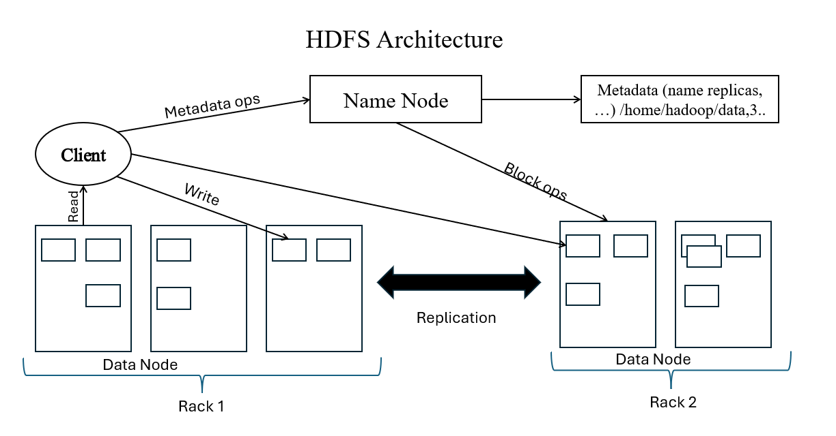
Figure 1 HDFS Architecture

Hadoop YARN
YARN stands for "Yet Another Resource Negotiator". It was introduced in Hadoop 2.0 to remove the bottleneck on Job Tracker which was present in Hadoop 1.0. YARN architecture basically separates resource management layer from the processing layer.

YARN also allows different data processing engines like graph processing, interactive processing, stream processing as well as batch processing to run and process data stored in HDFS (Hadoop Distributed File System) thus making the system more efficient.

The main components of YARN architecture, refer to figure 2, include:
- Client: It submits map-reduce jobs.
- Resource Manager: It is the master daemon of YARN and is responsible for resource assignment and management among all the applications. It has two major components:
    - Scheduler: It performs scheduling based on the allocated application and available resources.
    - Application manager: It is responsible for accepting the application and negotiating the first container from the resource manager.

- Node Manager: It takes care of individual node on Hadoop cluster and manages application and workflow and that particular node. Its primary job is to keep-up with the Resource Manager.
- Application Master: An application is a single job submitted to a framework. The application master is responsible for negotiating resources with the resource manager, tracking the status and monitoring progress of a single application.
- Container: It is a collection of physical resources such as RAM, CPU cores and disk on a single node.
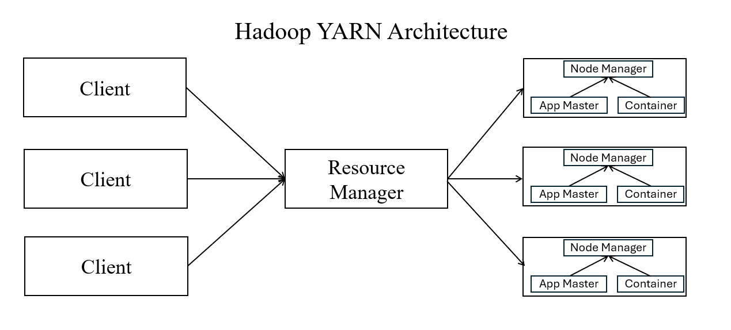
Figure 2. YARN Architecture

Datasets Stored in Hadoop

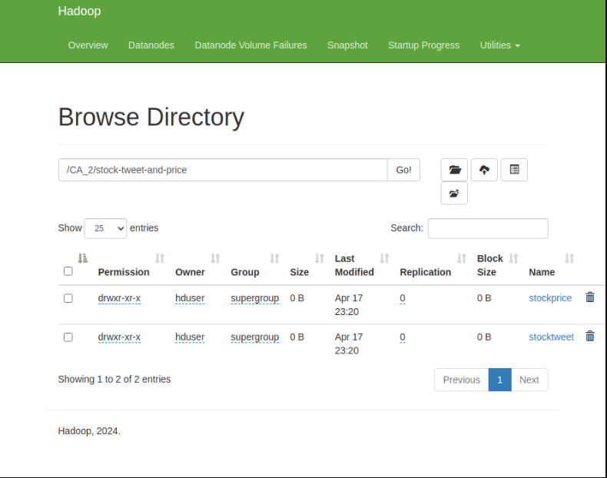
Figure 3 Datasets in Hadoop
The Figure 3 shows the datasets stored in HDFS. As observed, there are two main folders, stockprice folder contains thirty-eight datasets of different companies. On the other hand, stocktweet contains only one dataset with over 10,000 tweets.

Apache Spark
Apache Spark is a framework which can provide an improved alternative to the Map Reduce model. Spark unlike the map reduce model does not download the data to the disk in each step, instead the data is processed in the memory until the memory is full. Once the memory is full, it sends the data to the hard disk (Jayalakshmi & Krishna, 2018).

Figure 4 shows the architecture of spark:
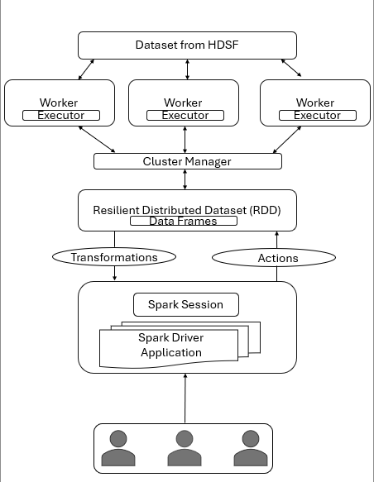
Figure 4 Apache Spark Framework

Exploratory Data Analysis
Tukey (1962) defined data analysis as: "Procedures for analysing data, techniques for interpreting the results of such procedures, ways of planning the gathering of data to make its analysis easier, more precise or more accurate, and all the machinery and results of (mathematical) statistics which apply to analysing data."

Apache Spark was a fundamental tool in this analysis, used for statistical computation, exploratory data analysis (EDA), and large-scale data processing. Its distributed architecture made it well-suited for handling the volume and complexity of the datasets. The entire analytical process is detailed in the following sections:

- Schema and Data Type Validation: The data types and schema of each dataset were examined to ensure that each column contained the appropriate data format for further analysis.

- Summary Statistics: Descriptive statistics were computed, including value counts, mean, standard deviation, minimum, and maximum values. This provided a general overview of the data's distribution and helped identify any inconsistencies.

- Handling Missing Data: A thorough inspection for missing values was performed. During this process, an anomaly was detected in the tweet dataset, some tweets were incorrectly categorized, due to misspelling in the tweet. These malformed tweets were removed.

- Data Filtering. The datasets were filtered to retain only the relevant information for the five target companies mentioned in Section 1. New datasets were created accordingly for focused analysis.

- Distributions Visualization: to gain a deeper understanding of the datasets, distribution plots were generated for key variables. These visualizations aided in identifying patterns and outliers, supporting further statistical analysis.

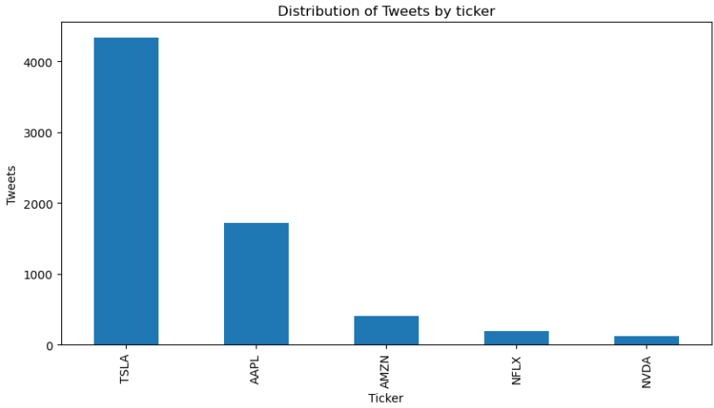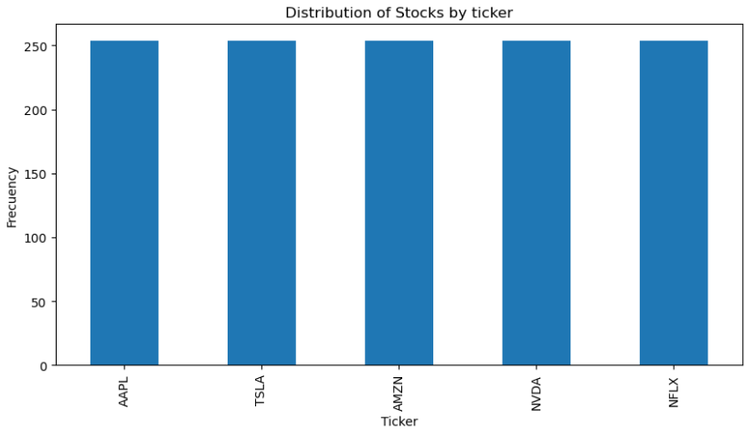
Figure 5 Distribution of Tweets Figure 6. Distribution of Stocks

In regard to continuing exploring the functions and capabilities of Apache spark, more distributions were plotted such as volume distribution, daily return distribution, daily volatility distribution, top 5 gainer stock, and top 5 loser stocks.

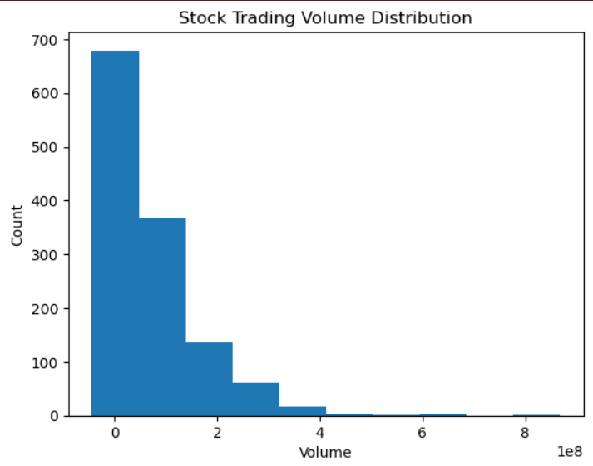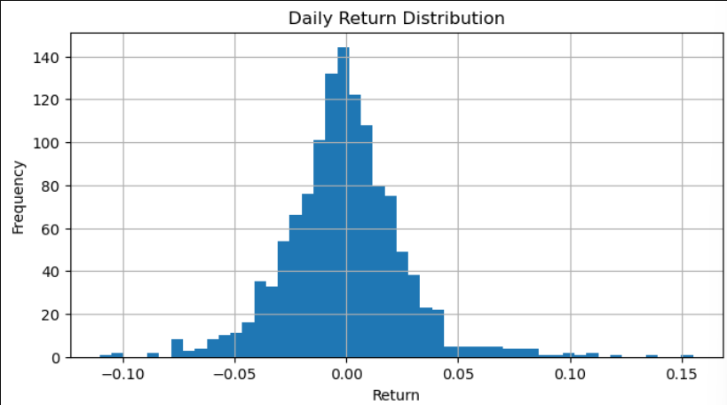
Figure 7 Distribution of stock trading volume. Figure 8. Distribution of daily return
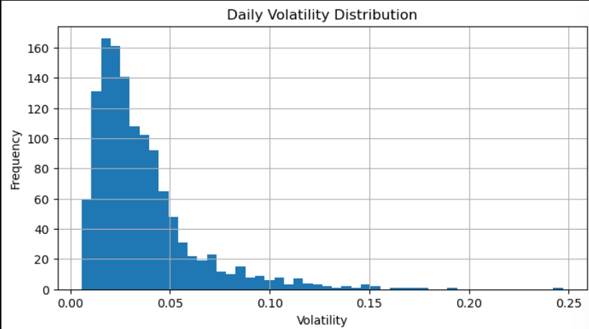
Figure 9. Distribution of daily volatility.

Apache Cassandra
Apache Cassandra is a free and open-source database management system designed to handle large volumes of data across multiple commodity servers (Carpenter & Hewitt, 2022).

Apache Cassandra was utilized as part of explore Not Only SQL (NoSQL) databases. This database allows to handle large volumes of unstructured or semi-structured data effectively, due to employment flexible schemas and various data models (IBM, 2012).

The datasets were stored into Cassandra. The table tweets contain the tweets about the 5 companies mentioned in Section 1, and the table tickers contain the stock information about these 5 companies.

The tweets and the stock market information were loaded from Cassandra, creating tweet_cassandra and stocks_cassandra dataframes, in order to confirm the correct storage.

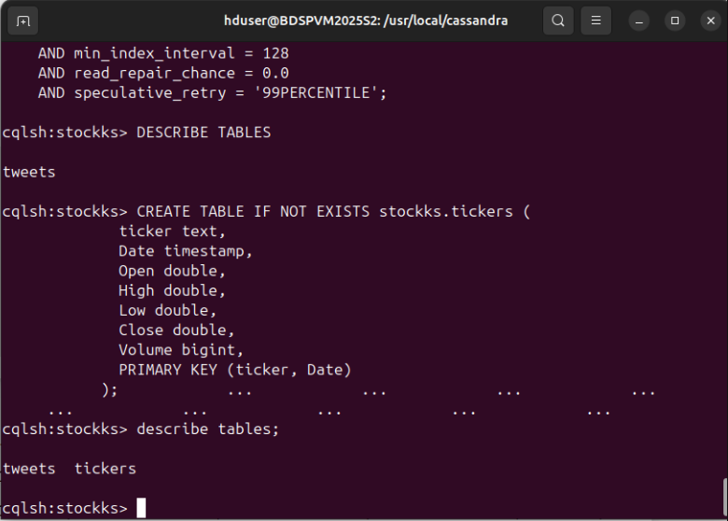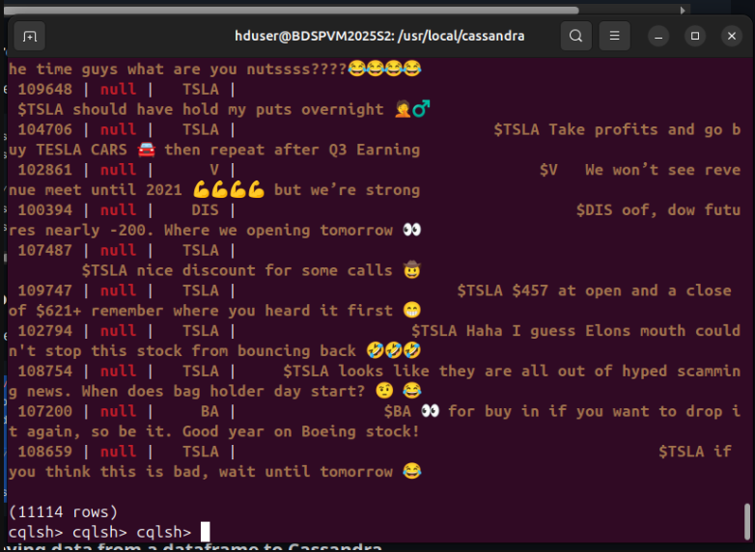
Figure 10. Tables in Cassandra database. Figure 11. Displaying Tweets on Cassandra bash.
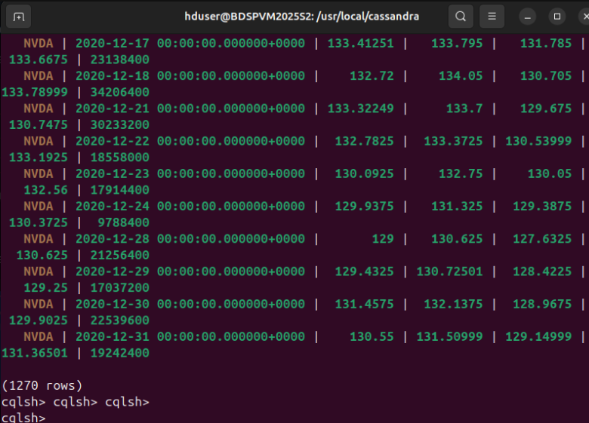
Figure 12. Displaying the stocks dataset in Cassandra bash.

The Figure 10 shows the datasets stored in Cassandra as tables tweet and tickers, meanwhile, Figure 11 is displaying the tweets, Figure 12 shows stock data into tickers table.

Spark SQL
Spark SQL is a module designed for processing structured and semi-structured data using SQL queries.

As in the previous step, the tweet and stock datasets were loaded into Spark SQL, creating a stocks database with two corresponding tables: tweets and tickers.

In order to explore the commands and functions of Spark SQL, tables were displayed, refer to Figure 13, Schemas were analysed, counted values and Missing values techniques were applied.

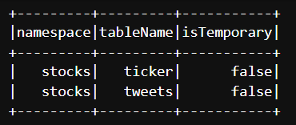
Figure 13. Display of tables in Spark SQL

Comparison of Databases Performance

MySQL VS MongoDB by YCSB

As part of the analysis, Yahoo Cloud Serving Benchmark (YCSB) was used to compare performance between MySQL and MongoDB utilizing the standard workloads A (50% Reads, 50% Updates), B (95% Reads, 5% Updates) and C (100% Reads).

The YCSB is an open-source specification and program suite for evaluating retrieval and maintenance capabilities of computer programs. It is often used to compare the relative performance of NoSQL database management systems (Cooper, et al., 2010).

Ljungdahl (2022), conducted a similar study, finding that MongoDB had lower latency and faster runtime for workloads exceeding 1,000 operations. For this project, the workload was configured at 1,000 operations, with the expectation of obtaining similar results.

The process consists in two phases, the first phase is composed for loading synthetic data into the target database (MySQL and MongoDB) to set up the testing data. In the case of this analysis, workloads A, B and C were loaded.

Second phase, run. In this phase, YCSB executes the defined workload operations against the database, collecting metrics for the analysis.

MySQL vs MongoDB Results
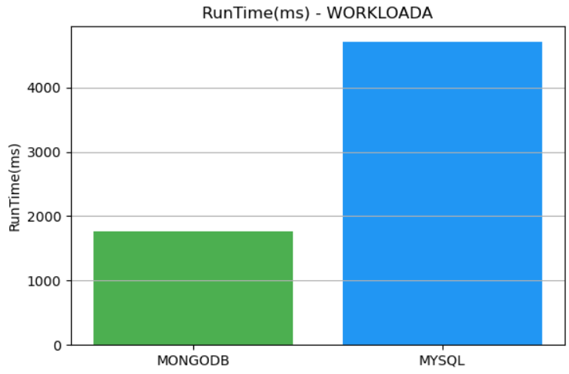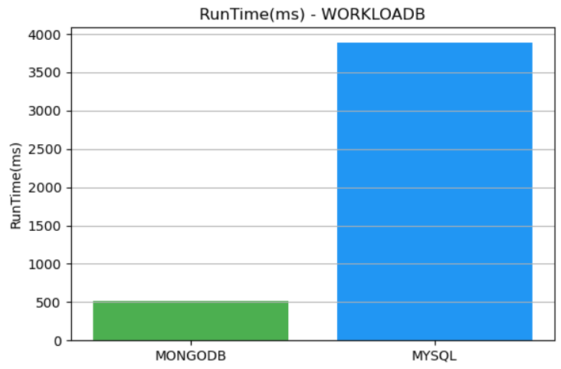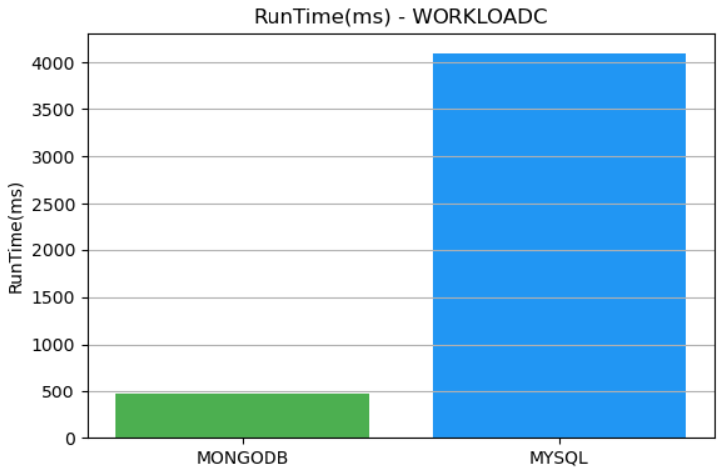
Figure 14. Workload A runtime results. Figure 15. Workload B runtime results. Figure 16. Workload C runtime results.

Table 1. T-Test Between MySQL and MongoDB Runtime Using YCSB Workloads
 | T-statistic | P-value
T-test | -6.4710 | 0.0066

MySQL vs MongoDB Result Conclusion

The experiment conducted using YCSB with workload A, B, and C, it is demonstrated that MongoDB consistently exhibits significant lower runtime (ms) in comparison to MySQL. Additionally, the t-test results showed a p-value lower than 0.05, leading to the rejection of the null hypothesis. This suggests that there is a statistically significant difference in execution times.

Spark SQL vs Cassandra

To further explore and evaluate databases performance, a comparison between Spark SQL and Cassandra was conducted. The experiment consisted in make 10 queries in each platform. These queries involved searching for a specific tweet in the tweets dataset, and search for a specific date in the tickers dataset. The execution time for each query was collect. In order to assess the performance plots were made.

A study showed that MySQL performs better than Cassandra, in read-heavy workloads with proper indexing (Karan, 2024). Considering that study, and Spark SQL's distributed architecture and in-memory processing capabilities, it's expected to achieve lower query execution times, particularly for large-scale analytical queries.

7.2.1 Spark SQL vs Cassandra Results

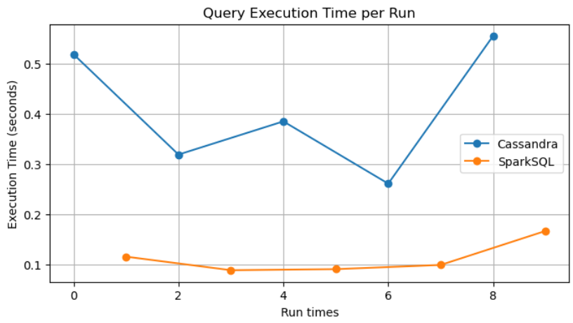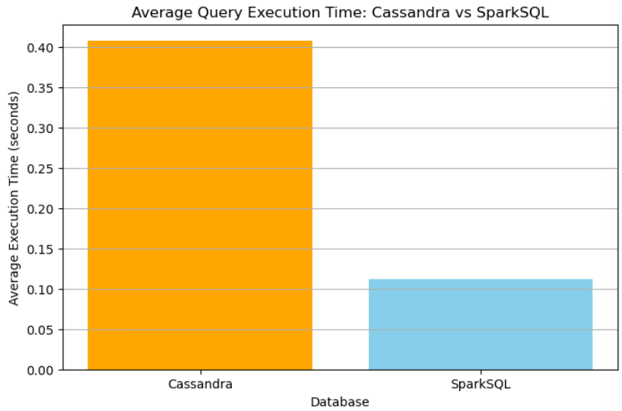
Figure 17. Plot of query execution time by run. Figure 18. Average of query execution time.

Table 2. t-test between Spark SQL and Cassandra on tweets dataset by execution time
 | P-value | T-statistic
t-test | 0.0104 | 4.204

Cassandra vs Spark SQL Result Conclusion

The experiment was conducted by making ten queries to each database. The charts clearly demonstrate that Spark SQL exhibits higher performance than Cassandra. However, the t-test results showed a p-value lower than 0.05, leading to the rejection of the null hypothesis. This suggests that there is a statistically significant difference in execution times.

Sentiment Analysis

Numerous studies have explored the application of sentiment analysis in predicting stock market movements, highlighting the significant role of public sentiment derived from various sources such as social media, news articles and financial reports.

A study from Stanford University analysed Twitter data to assess its predictive power on stock prices. The research indicated that sentiments expressed on Twitter, can lead to notable fluctuations in stock prices (Palomo, 2023).

With the purpose of explore two different sentiment analysis methods, for the project, TextBlob and SentimentIntensityAnalyzer are implemented. These algorithms were used to perform sentiment analysis on tweets related to each company (AMZN, AAPL, NFLX, NVDA, and TSLA). Usually, these analyses provide a categorical sentiment output: Positive, Negative, or Neutral. However, to achieve a more nuanced analysis, the numerical polarity scores were employed. The polarity score ranges go from -1.0 to 1.0, where:

- -1.0 indicates a highly negative sentiment.

- 0.0 represents a neutral sentiment.

- 1.0 signifies a highly positive sentiment.

By utilizing these numerical values, the sentiment analysis captures more variations in sentiment intensity, offering a more detailed interpretation than the standard categorical labels according to the study of Maqbool, et al. (2023). Additionally, the research of Bharathi & Geetha (2017) emphasized the importance of efficiently scoring emotions from stock news to anticipate market changes.

TextBlob

TextBlob is a Python library for processing textual data. It provides a simple API for common Natural Language Processing (NLP) tasks, including part-of-speech tagging, noun phrase extraction, translation, and especially sentiment analysis.

Fajrul, et al. (2023) developed research focused on predicting stock price movements by combining TextBlob sentiment analysis with stock prices. The study highlights TextBlob's utility in financial sentiment analysis, providing insights into how public sentiment, as captured from various textual sources, can influence stock market behaviour.

VADER’s SentimentIntensityAnalyzer()

SentimentIntensityAnalyzer() is a class from the VADER (Valence Aware Dictionary and sEntiment Reasoner) sentiment analysis tool, part of the nltk.sentiment.vader module in Python's NLTK library.

The work of Baruah & Changkakati (2024) demonstrates a significant correlation between sentiment and stock price movements, suggesting that positive or negative sentiments expressed on Twitter could predict daily returns in stock market.

In the research of Sanyal & Kumar (2021) both TextBlob and VADER, were evaluated on feedback data, finding that VADER has superior performance in detecting negative sentiments. Furthermore, another study on social media text, found that VADER had an accuracy rate of 79%, outperforming TextBlob’s 73%, highlighting VADER’s effectivity (Syahirah, et al., 2020).

Comparison between VADER and TextBlob
To compare the performance of VADER and TextBlob sentiment analysis techniques, visualizations and statistical metrics were utilized. Sentiment distributions were plotted (Refer to Figure 19 and 20), and comparison tables were created. Additionally, a Chi-squared test was applied to statistically analyse whether there were significant differences between the sentiment classifications.

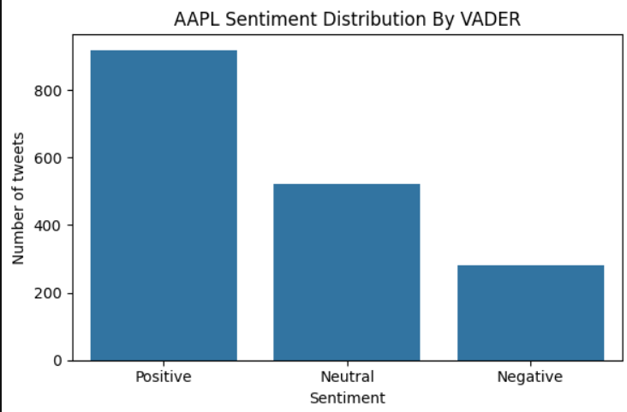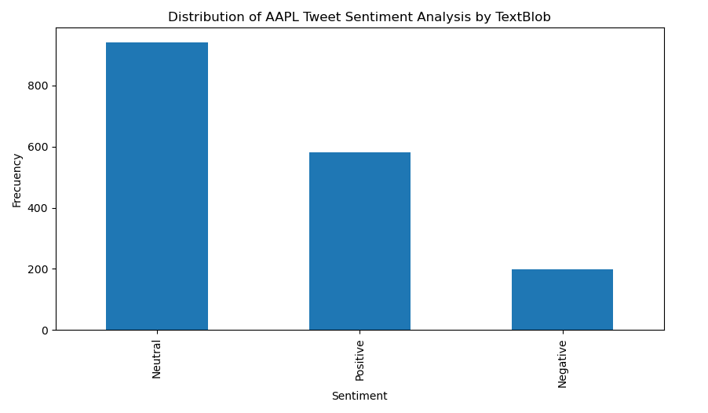
Figure 19. AAPL sentiment distribution by VADER. Figure 20. AAPL sentiment distribution by TextBlob.

Table 3. Comparison of VADER and TextBlob on AAPL Tweet Sentiment Analysis
Sentiment Analysis Technique | Positive | Neutral | Negative
VADER | 918 | 522 | 280
TextBlob | 942 | 580 | 199

Table 4. Results of VADER and TextBlob Chi-Square test
 | Positive | Neutral | Negative
p-value | 0.1572 | 0.1572 | 0.1572

VADER vs TextBlob Result Conclusion

The Table 4 shows that the p-value is greater than 0.05, failing to reject the null hypothesis, indicating that there are no statistical differences between the sentiment categories, positive, neutral, and negative, provided by VADER and TextBlob.

Streaming Big Data
Streaming big data from public APIs involves collecting and processing large volumes of real-time data from publicly available sources, such as social media platforms, news feeds, financial tickers or IoT sensors.

A study demonstrates the use of Apache Spark for real-time processing of extensive oceanographic datasets, highlighting the potential of streaming frameworks in handling large scientific data (Dahala, et al., 2019).

Another study distinguished the Apache Kafka’s enterprise messaging system to connect multiple systems and also the powerful streaming library to perform real-time data processing (Faisal, 2021).

For this project, Apache Spark and Apache Kafka were used to load and process streaming Big Data form Reddit’s API.

Spark Streaming is an extension of the core Spark API that enables scalable, high-throughput, fault-tolerant stream processing of live data streams.

Kafka Streams is a client library for building applications and microservices, where the input and output data are stored in an Apache Kafka cluster.

The complete analysis will be detailed in the next section.

Big Data Steaming by Apache Spark

- API Client. Connect to Reddit’s API using praw library, the first phase requires to set configurations to initialize the API client.
- Data ingestion. The data about AAPL stock were obtained from Reddit’s post through Spark. 100 posts were downloaded.
- Data processing. The obtained data were stored locally as a .json file in order to analyse it. Refer to Figure 21.
- Exploratory Data Analysis. Statistical analyses were performed, such as check schema types, count total posts, count of post by author.
- Sentiment Analysis. Sentiment analyses techniques were applied on AAPL’s posts from reddit, with the motivation to continue exploring and utilising NLP algorithms. Refer to Figure 22.

Results

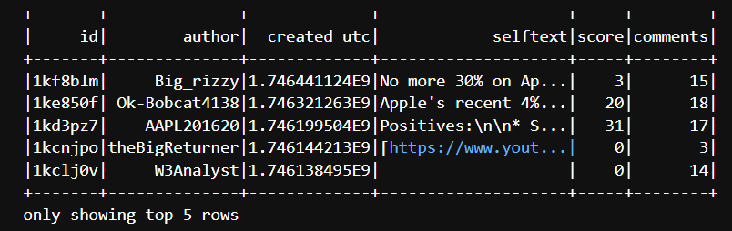
Figure 21. Preview of post obtained from Reddit.

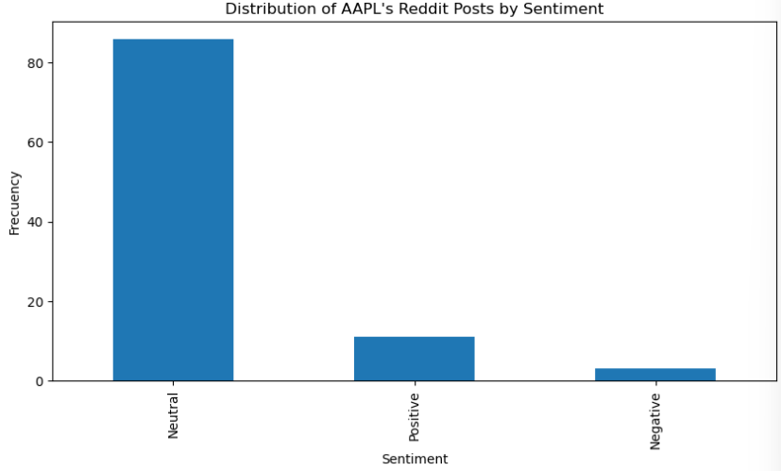
Figure 22.AAPL Sentiment distribution.
The figure 22, shows the result of a sentiment distribution applied to posts obtained from Reddit about AAPL. These posts were obtained using Apache Spark Streaming.

Big Data Steaming by Apache Kafka

- API Client. Apache Kafka was set with the necessary configuration for Reddit’s API Client.
- Kafka Producer. Kafka Producer was configurated to send records about AAPL from Reddit’s posts to Kafka topics.
- Kafka Consumer. Kafka Consumer was run to read the records in real-time from Kafka topics.

Results
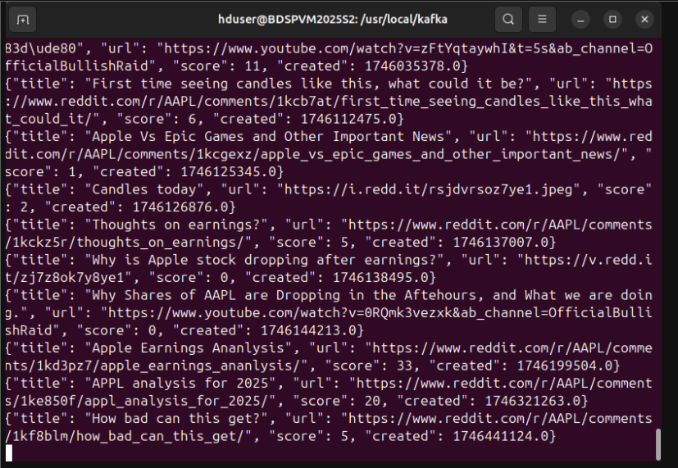
Figure 23. Streaming post from Reddit by Kafka.
The Figure 23 shows posts about AAPL obtained from Reddit in real time streaming. This technique allows analyst to apply data analysis techniques to big data.

Forecasting Stock Market Methodology

In this part of the project, the processes, methodologies, techniques, and models mentioned in Section 1 will be described in the following section.

Data Splitting

Every dataset was partitioned into training and testing sets, with 80% of the data used for training and the remaining 20% for testing. The 80/20 ratio aligns with the Pareto Principle, suggesting that roughly 80% of effects come from 20% of causes. While not a strict rule, this principle has influenced the adoption of the 80/20 split in various applications (Roshan, 2022).

Check for Stationarity

Check for stationarity is a crucial step in time series analysis, particularly when employing models that require this property. Models such as ARIMA, SARIMA and SARIMAX assume that the underlying time series is stationary.

There are two ways to check for stationarity:

- Visual inspection. Plotting the time series to identify trends, seasonality or changing variance (Hyndman & Athanasopoulos, 2018).

- Statistical testing. The Augmented Dickey-Fuller (ADF) test assesses whether a time series is stationary. The null hypothesis posits that the series has a unit root (it is non-stationary), while the alternative hypothesis suggests that the series is stationary. Based on the test results, we either reject or fail to reject the null hypothesis (Dickey & Fuller, 1979).

The AMZN dataset was analysed, and the results indicated that the time series was non-stationarity. In order to correct this issue, differencing was applied. Differencing, subtracts the previous observation from the current one to remove trends, stabilizing the mean.

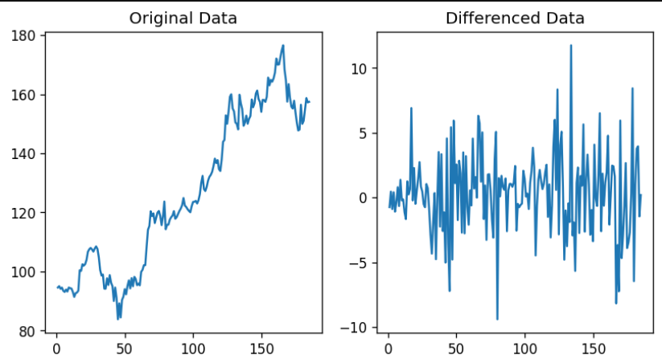
Figure 24. AMZN original data. Figure 25. AMZN differenced data.

Scaling

Scaling before applying time series analysis is particularly important. The work of Sarle (1997) explains the importance of this, and theorical considerations when applying neural networks models. The main advantage of scaling is to avoid attributes in greater numeric ranges dominating those in smaller numeric ranges. Another advantage is to avoid numerical difficulties during the calculation. Because kernel values usually depend on the inner products of feature vectors, large attribute values might cause numerical problems.

Both training and testing data were scaled in the range of 0 to 1, by Min-Max Scaling method.

Model Selection

SARIMAX

The SARIMAX (Seasonal AutoRegressive Integrated Moving Average with Exogenous regressors) model is a powerful statistical tool for time series forecasting. It extends the ARIMA model by incorporating both seasonal components and external variables (exogenous regressors), making it particularly useful for complex datasets exhibiting seasonality and influenced by external factors (Swain, et al., 2018).

The project of Alharbi & Csala (2022) implemented SARIMAX model to forecast the power sector based on historical data. The SARIMAX model was effective in capturing linear trends and seasonality than ARIMA. Additionally, by integrating exogenous factors, the model effectively reduced error values and improved overall accuracy.

Formula:

$\begin{aligned}Y_{t}​=c+ ϕ_{1}Y_{t-1}​+ϕ_{2}Y_{t-2}+…+ θ_{1}ε_{t-1}​+θ_{2}ε_{t-2} +…+Seasonal terms+{βX}_{t}+ ε_{t} \#\end{aligned}$Eq.1

Here, $Y_{t}​$ stands for value at time t, c stands for constant term, ϕ stands for autoregressive (AR) coefficient, $θ$ stands for moving average (MA) coefficients, $ε_{t}$ stands for white noise (error), ${βX}_{t}$ stands for influence of exogenous variables, and, Seasonal terms involve seasonal AR and MT with seasonal lags.

XGBoost

XGBoost (Extreme Gradient Boosting) is a powerful and efficient machine learning algorithm based on decision trees. It belongs to a class of techniques called boosting, where multiple weak learners (typically decision trees) are trained sequentially to correct the errors of the previous ones.

A research made by Gifty & Li (2024) compared the performance of LSTM, ARIMA, and XGBoost in predicting Google's stock prices, finding that XGBoost achieved a high R-squared value of 99.47% with optimized parameters.

Formula:

$$ŷ_{i}=\sum_{k=1}^{K}{f_{k}\left(x_{i}\right), f_{k }∈F }$$
Eq. 2

Here, $ŷ_{i}$ stands for predicted value for instance i, $f_{k}$ stands for the weak learner decision tree, $f$ stands for the space of all regression trees, and, K stands for the total number of trees.

LSTM

Long Short-Term Memory (LSTM) networks are a specialized type of Recurrent Neural Network (RNN) designed to address the vanishing gradient problem and capture long-range dependencies in sequential data by using a gated architecture to control the flow of information (Hochreiter & Schmidhuber, 1997).

In the study of Jin, et al. (2020), the stock market was forecasted by combining sentiment analysis with LSTM networks. The results indicate that the LSTM model can improve prediction accuracy by incorporating sentiment analysis as exogenous data.

Gates:

      - Forge Gate:

$$f_{t}​=σ( W_{f}x_{t}​+U_{f}h_{t-1}+b_{f})$$
Eq. 3
Eq. 3, decides what to forget from the previous cell state.

      - Input Gate:

$$i_{t}​=σ( W_{i}x_{t}​+U_{i}h_{t-1}+b_{i})$$
Eq. 4
Eq. 4, controls what current information to store.

      - Candidate Cell State:

$$č_{t}=tanh( W_{c}x_{t}​+U_{c}h_{t-1}+b_{c})$$
Eq. 5
Eq. 5, proposes new candidate values to add to the cell state.

      - Update Cell State:
$$c_{t}​= f_{t}⊙c_{t-1}​+i_{t}⊙č_{t}$$
Eq. 6
Eq. 6, combines the old cell state and the candidate using gates.

      - Output Gate:

$$o_{t}=σ( W_{o}x_{t}​+U_{o}h_{t-1}+b_{o})$$
Eq. 7
Eq. 7, determines what part of the cell state goes to the hidden state.

      - Hidden State Update:

$$h_{t}​= o_{t}⊙tanh⁡(c_{t}​)$$
Eq. 8
Eq. 8 is the output for this time step.

Where:

σ stands for the sigmoid activation (output between 0 and 1), tanh stands for hyperbolic tangent (output between -1 and 1), ⊙ stands for the element-wise multiplication, W, U, and, b learnable weight matrices and biases.

GRU

Gated Recurrent Units (GRU) are a gating mechanism in recurrent neural networks (Cho, et al., 2014). The GRU is like a LSTM with a gating mechanism to input or forget certain features (Gers, et al., 1999).

In a comparative study using sentiment analysis from tweets to forecast S&P 500 prices, the GRU outperformed LSTM in terms of both speed and accuracy (Bhavani, et al., 2022).

Gates:

- Update Gate:

$$z_{t}​=σ( W_{z}x_{t}​+U_{z}h_{t-1}+b_{z})$$
Eq. 9

Eq. 9 controls how much of the past state to keep.

- Reset Gate:

$$r_{t}​=σ( W_{r}x_{t}​+U_{r}h_{t-1}+b_{r})$$
Eq.10

Eq. 10 controls how much of the past state to forget when computing the candidate.

- Candidate Hidden State:

$$ĥ_{t}​=tanh( W_{h}x_{t}​+U_{h}(r_{t}⊙h_{t-1})+b_{h}$$
Eq.11

Eq. 11, selects a candidate for the new hidden state, using reset-gated previous state.

- Final Hidden State:

$$h_{t}​=(1-z_{t})​⊙h_{t-1}+z_{t} ⊙ĥ_{t}$$
Eq.12

Eq. 12 interpolates between old hidden state and new candidate.

Where:

σ stands for the sigmoid activation (output between 0 and 1), tanh stands for hyperbolic tangent (output between -1 and 1), ⊙ stands for the element-wise multiplication, W, U, and, b learnable weight matrices and biases.

Prophet

Facebook Prophet is a modern forecasting tool designed to handle time series data with multiple seasons and holidays. It is known for its robustness to missing data, outliers, and its ability to model complex seasonality (daily, weekly, yearly). The model’s flexibility and ease of use have made it popular for various forecasting tasks. Prophet is particularly useful when dealing with long-term forecasting, as it can account for multiple cycles and trends over extended periods.

Prophet models a time series as:

y(t)=g(t)+s(t)+h(t)+εt​
Eq. 13

Here, g(t) stands for trend, s(t) stands for seasonality, h(t) stands for holidays, εt is the error rate.
Mohan, et al. (2019) in their study on stock price prediction using news sentiment analysis, found that Prophet model’s accuracy depends upon the amount of the training data provided.

Optimizers

Optimizers are used in deep learning to minimize loss functions during model training.

A study by Makinde (2024) compared the effectiveness of Adam and NAG optimizers on LSTM and GRU models using AAPL’s stock data. The GRU model optimized with Adam achieved the lowest RMSE, outperforming other model-optimizer combinations.
Considering the below citation, Adam optimizer was selected and applied to LSTM and GRU models during training.
Adam (Adaptive Moment Estimation) optimizer combines the strengths of two other well-known techniques (Momentum and RMSprop) to deliver a powerful method for adjusting the learning rates of parameters during training (Diederik & Ba, 2014).

Hyperparameters Tuning

Hyperparameters tuning is a process which aims to identify the optimal configuration of parameters that maximize the model’s performance (Feurer & Hutter, 2019). This is a critical step in machine learning, especially when working with neural networks.

A study analysed 26 machine learning algorithms across 250 datasets, totalling over 28 million algorithms runs. The findings suggest that the performance by hyperparameter tuning variate across algorithms and datasets (Moshe, 2022). Considering this study, the models mentioned in Section 1 were hyperparameter tuned utilizing the following techniques:

- Grid Search
This method involves exhaustively searching through a manually specified subset of the hyperparameter space. A grid search algorithm must be guided by some performance metric, typically measured by cross-validation on the training set or evaluation on a hold-out validation set (Hsu, et al., 2016).

- Random Search
Instead of evaluating all combinations, random search selects random combinations of hyperparameters to evaluate. The study of Bergstra & Bengio (2012) have shown that random search can be more efficient than grid search, especially when only a few hyperparameters significantly influence the model's performance.

Hyperparameters tuning Results

Table 5. Hyperparameters obtained for SARIMAX model.
 | p | d | q
SARIMAX | 2 | 0 | 3

Table 6. Hyperparameters obtained for XGBoost model.
 | Subsample | n_estimators | max_depth | learning_rate | colsample_bytree
XGBoost | 0.8 | 300 | 7 | 0.05 | 1.0

Table 7. Hyperparameters obtained for LSTM model.
 | Units | Activation | Recurrent_activation
LSTM | 32 | Tanh | sigmoid

Table 8. Hyperparameters obtained for GRU model.
 | Units | Dropout | Activation | Recurrent_activation
GRU | 128 | 0.2 | Tanh | sigmoid

Table 9. Hyperparameters obtained for Prophet model.
 | Change_prior_scale | Seasonality_prior_scale | Seasonality_mode
Prophet | 0.1 | 1.0 | additive

Statistical Metric Evaluations

Evaluating time series forecasting models is crucial for understanding their performance and reliability.

A study on hybrid time series by Alsalem (2025) evaluated various models using Root Mean Squared Error (RMSE), Mean Absolute Error (MAE), and R-squared (R²). Research on stream-flow forecasting by Hu, et al. (2020) employed LSTM models and assessed their performance using the same statistical metrics. Another study on air pollution forecasting by Ghafariasl, et al. (2024), also used these metrics to evaluate model performance.

These examples highlight that many studies on time series forecasting rely on RMSE, MAE and R² as primary metrics for assessing accuracy. These same metrics were used to evaluate the models, mentioned in Section 1.The statistical evaluation metrics are detailed below:

- Mean Absolute Error (MAE). This method measures the average magnitude of errors between predicted and actual values, without considering their direction.

Formula:

$$MAE=\frac{1}{n}\sum_{i=1}^{n}{|ŷ_{i}-y_{i}|}$$
Eq. 14

- Root Mean Square Error (RMSE). It measures the square root of the average squared differences between the predicted and the actual values.

Formula:

$$RMSE=\sqrt{\frac{1}{n}\sum_{i=1}^{n}{{(ŷ_{i}-y_{i})}^{2}}}$$
Eq. 15

- R² Score. The R² score measures how well the predicted values from a model approximate the actual data.

Formula:

$$R^{2}=1+\frac{\sum_{i=1}^{n}{{(y_{i}-ŷ_{i})}^{2}}}{\sum_{i=1}^{n}{{(y_{i}-yˉ)}^{2}}}$$
Eq. 16

Results

Statistical Metrics Evaluation Results

Table 10. Statistical Evaluation
Model | RMSE | MAE | R² Score
SARIMAX | 5.09 | 4.04 | -0.35
XGBoost | 1.05 | 0.72 | 0.97
LSTM | 12.11 | 7.97 | 0.52
GRU | 3.23 | 2.30 | 0.16
Prophet | 9.84 | 7.41 | 0.96

The XGBoost model exhibits the lowest RMSE (1.05) and MAE (0.72), and the highest R² Score (97%), indicating excellent predictive accuracy. The GRU model outperforms LSTM in all metrics, suggesting better handling of the time series data in this context. SARIMAX shows higher error metrics and negative R² Score, indicating poor performance. Prophet despite its higher RMSE and MAE, achieves a considerable high R² Score (96%) indicating that it captures the overall trend well. LSTM has the higher RMSE and MAE among the models, but a moderate R² Score suggest that it captures some patterns.

Actual vs Forecast Prices Plots

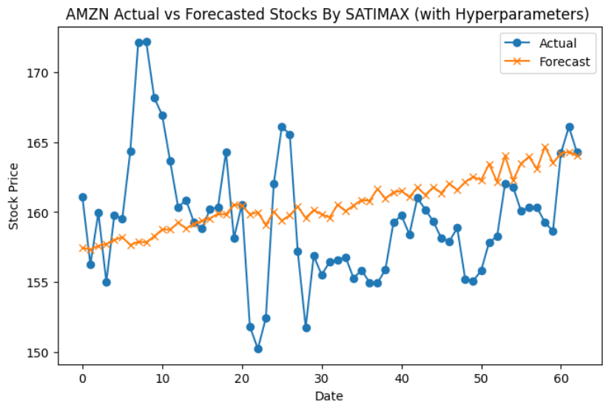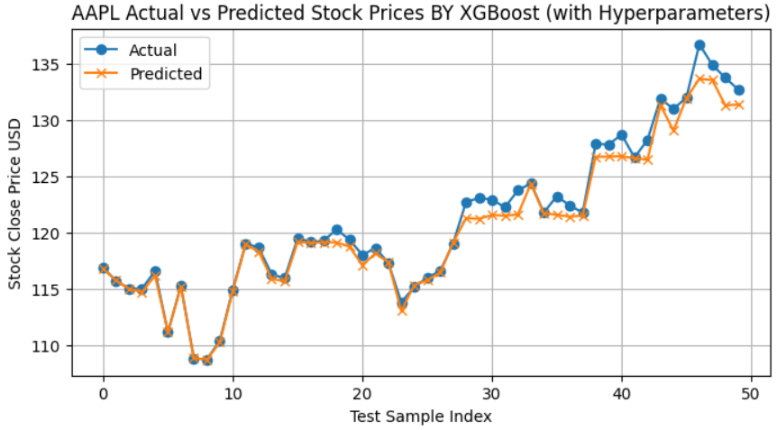
Figure 26. AMZN actual vs forecasted by SARIMAX. Figure 27. AAPL actual vs forecasted by XGBoost.

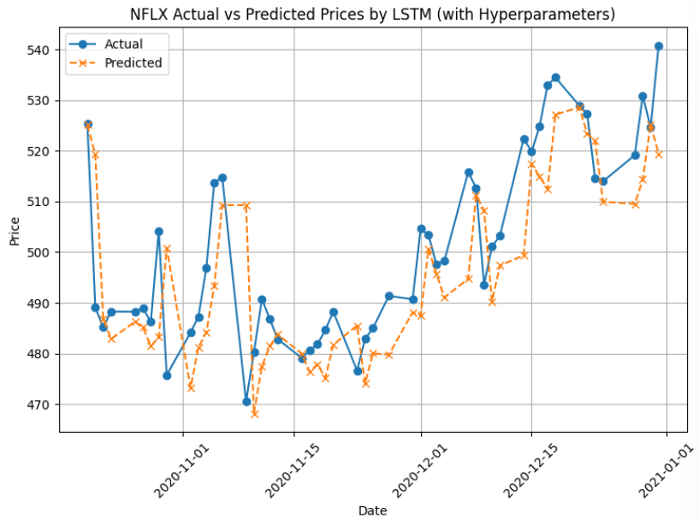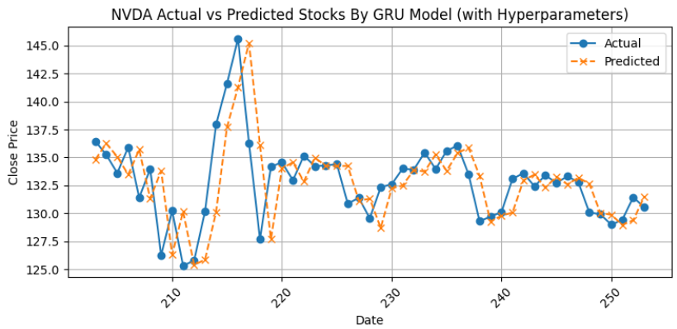
Figure 28. NFLX actual vs forecasted by LSTM. Figure 29. NVDA actual vs forecasted by GRU.

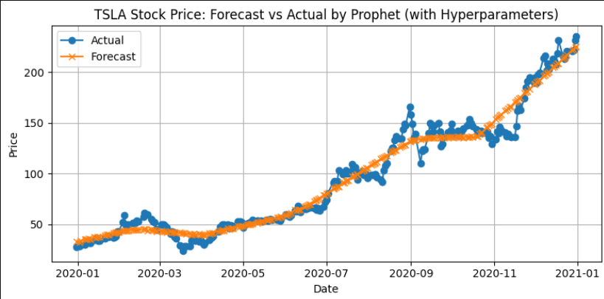
Figure 30. TSLA actual vs forecasted by Prophet.

The charts show that SARIMAX model (refers to Figure 26) captured the general trend well but lack precision the short-term fluctuation. The XGBoost model (refers to Figure 27) followed the actual values showing precision during high volatility, indicating strong performance. The LSTM model (refers to Figure 28) captured the peaks effectively, but some short-term variabilities were missed. The GRU model (refers to Figure 29) exhibited minor deviation, indicating robust performance. The Prophet (refers to Figure 30) model captured the overall trend; however it did not perform well in short-term variations.

Interactive Dashboard

To conclude this project, an interactive dashboard (refer to Figure 31) was created. A dashboard is a type of graphical user interface which provides at-a-glance view of relevant data (Tableau, 2024).

In this case, the dashboard (refer to Figure 31) was designed to display a seven-day price forecasting of the stocks mentioned in Section 1. Tufte’s six principles were the cornerstone of the designed.

In his book “ The visual display of quantitative information,” Tufte (1983) outlined six principles focused on creating a clear, accurate, and insightful visual representation of data. These principles include:

- Proportional representation:
The representation of the numbers should be directly proportional to the numerical quantities they represent.
- Clear and detailed labelling:
Graphics should be clearly labelled to prevent distortion and ambiguity.
- Show data variation, not design variation:
The focus should be on displaying the actual data variation, not on creating unnecessary design variations.
- Use standardized units:
In time-series displays of monetary data, it is better to use deflated and standardized unit of measurements rather than nominal units.
- Match variable dimensions to data dimensions:
The number of information-carrying dimensions in a graphic should not exceed the number of dimensions in the data.
- Maintain contextual integrity:
Graphics should not quote data of the context, but rather provide a complete and balanced view of the data.
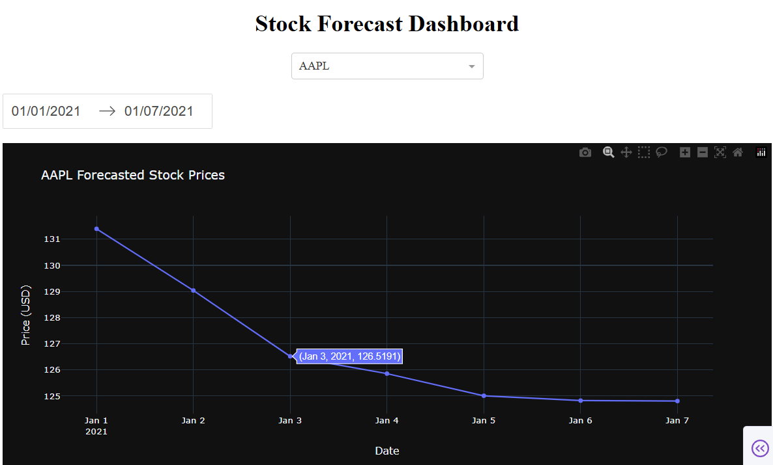
Figure 31. Interactive dashboard.

Considering Tufte’s principles, the Figure 31 represents the values using a line chart, aligning with Principle 1. As Principle 2 suggest, the dashboard includes clear labels such as, the title, the timeline, prices, and stock names. The line chart is simple and easy to interpret, avoiding any complex or decorative elements in a 2D plane, in accordance with Principles 3 and 5. Prices were displayed in USD, as recommended by principle 4. The chat displays the compete forecasted week, ensuring no data is omitted, as emphasized in Principle 6.

Conclusion

Forecasting stock market prices remains a complex challenge due to the multitude of influencing factors. This project aimed to address this complexity by employing a comprehensive analytical approach.

The study utilized historical stock data from companies such as AAPL, AMZN, NFLX, NVDA, and TSLA, supplemented with exogenous data from Twitter to capture market sentiment.
Exploratory Data Analysis (EDA) was conducted to understand data distributions and trends, and stationarity tests ensured the suitability of time series models. Various forecasting models were evaluated, including SARIMAX, XGBoost, LSTM, GRU, and Prophet. Among these, the XGBoost model demonstrated superior performance, achieving the lowest Mean Absolut Error (MAE) of 0.72, and Root Mean Square Error (RMSE) of 1.05, and the highest R² Score of 0.97, indicating its effectiveness in capturing short-term market variations.

To enhance the analysis with real-time data, Apache Kafka and Spark Streaming were implemented as a streaming pipeline to ingest Reddit posts. This integration allowed for the incorporation of live social media sentiment into the forecasting models, providing a mode dynamic and responsive analytical framework.

For big data storage and processing, Hadoop's HDFS was implemented as the file storage system. A comparative analysis of SQL (MySQL, Spark SQL) and NoSQL (MongoDB, Cassandra) databases was conducted. Results indicated that MongoDB required less runtime than MySQL based on YCSB metrics, while Spark SQL outperformed Cassandra in query execution speed.

Additionally, sentiment analysis was performed using VADER and TextBlob algorithms. Statistical evaluation through the Chi-Squared test revealed no significant differences between them.

The culmination of these analyses was presented through an interactive dashboard developed using Dash, facilitating real-time data visualization and user engagement.

In summary, this project integrated advanced forecasting models, big data technologies, and sentiment analysis to provide a multifaceted approach to stock market prediction. The findings underscore the potential of combination deep learning models with big data frameworks and sentiment analysis for enhanced predictive accuracy.

References
Alharbi, F. & Csala, D., 2022. A Seasonal Autoregressive Integrated Moving Average with Exogenous Factors (SARIMAX) Forecasting Model-Based Time Series Approach. MDPI Journals, 7(94).
Alsalem, k., 2025. A hybrid time series forecasting approach integrating fuzzy clustering and machine learning for enhanced power consumption prediction. Scientific Reports, 15(6447).
Baruah, A. & Changkakati, B., 2024. VADER SENTIMENT ANALYSIS ON TWITTER: PREDICTING PRICE TRENDS AND DAILY RETURNS IN INDIA’S STOCK MARKET. Bangladesh Journal of Multidisciplinary Scientific Research, 9(2226), pp. 45-54.
Bergstra, J. & Bengio, 2012. Random Search for Hyper-Parameter Optimization. Journal of Machine Learning Research, 13(10), p. 281−305.
Bharathi & Geetha, 2017. Sentiment Analysis for Effective Stock Market Prediction. International Journal of Intelligent Engineering and Systems, 10(0630.16), pp. 146-154.
Bhavani, Venkata & Chakravarthy, 2022. Comparative Analysis between LSTM and GRU in Stock Price Prediction. 2022 International Conference on Edge Computing and Applications (ICECAA), Issue 978-1-6654-8232-5.
Carpenter, J. & Hewitt, 2022. Cassandra: The definitive Guide. 3 ed. s.l.:O'Reilly Media.
Cho, et al., 2014. Learning Phrase Representations using RNN Encoder-Decoder for Statistical Machine Translation. arXiv, Volume 1.
Cooper, B. et al., 2010. Benchmarking Cloud Serving Systems with YCSB. Yahoo! Research.
Dahala, Loup, Arifuzzaman & Abdelguerfi, 2019. Distributed Streaming Analytics on Large-scale Oceanographic Data using Apache Spark, New Orleans: Cornell University.
Dickey & Fuller, 1979. Distribution of the Estimators for Autoregressive Time Series with a Unit Root. Journal of the American Statistical Association, 76(366), pp. 427-431.
Diederik, K. & Ba, J., 2014. Adam: A Method for Stochastic Optimization. arXiv, 1(1412.6980.).
Faisal, K., 2021. Apache kafka with real-time data streaming, s.l.: s.n.
Fajrul, M., Firmansyah, Tjanjono & Akbar, 2023. Utilization of LSTM (Long Short Term Memory) Based Sentiment Analysis for Stock Price Prediction. Asian Journal of Social and Humanities, 1(1241-1255), p. 12.
Feurer, M. & Hutter, F., 2019. Hyperparameter Optimization. In: Automated Machine Learning. The Springer Series on Challenges in Machine Learning. Freiburg: Springer, pp. 3-38.
Gers, Schmidhuber & Cummins, 1999. Learning to forget: Continual prediction with LSTM. 9th International Conference on Artificial Neural Networks: ICANN '99, 1999(ISBN 0-85296-721-7), pp. 850-855.
Ghafariasl, Zeinalnezhad & Ahmadishokooh, 2024. Optimizing PM2.5 Forecasting Accuracy with Hybrid Meta-Heuristic and Machine Learning Models. Cornell University.
Gifty, A. & Li, Y., 2024. A Comparative Analysis of LSTM, ARIMA, XGBoost Algorithms in Predicting Stock Price Direction. Engineering And Technology Journal, Volume 9, pp. 4978-4986.
Gupta, R. & Chen, 2020. Sentiment Analysis for Stock Price Prediction. 2020 IEEE Conference on Multimedia Information Processing and Retrieval (MIPR).
Hochreiter & Schmidhuber, J., 1997. Long Short-Term Memory. Neural Computation, Volume 9.
Hsu, C.-W., Chang & Lin, 2016. A Practical Guide to Support Vector Classification, Taipei: NTU.
Hu, Y., Yan, L., Hang, T. & Feng, J., 2020. Stream-Flow Forecasting of Small Rivers Based on LSTM. Cornell University, Issue arXiv:2001.05681.
Hyndman & Athanasopoulos, 2018. 8.1 Stationarity and differencing. In: Forecasting: Principles and Practice. s.l.:OTexts.
IBM, 2012. What is a NoSQL database?. [Online]
Available at: https://www.ibm.com/think/topics/nosql-databases
[Accessed april 2025].
Jayalakshmi & Krishna, 2018. Performance evaluation of DNN with other machine learning techniques. Journal of King Saud University – computer and information sciences.
Jin, Z., Yang & Liu, Y., 2020. Stock closing price prediction based on sentiment analysis and LSTM. Neural Comput & Applic, Volume 32, p. 9713–9729.
Judge, P., 2012. Doug Cutting: Big Data Is No Bubble. [Online]
Available at: http://www.silicon.co.uk/workspace/doug-cutting-big-data-is-not-a-bubble-96694
[Accessed 2025].
Karan, 2024. Comparing High Read/Write Performance of Database Systems: MySQL, MongoDB, Cassandra, Snowflake, and Redshift. Medium, p. 1.
Ljungdahl, V., 2022. Performance comparison of distributed MySQL and. Blekinge Institute of Technology, Issue 37179.
Makinde, A., 2024. Optimizing Time Series Forecasting: A Comparative Study of Adam and Nesterov Accelerated Gradient on LSTM and GRU networks Using Stock Market data. arXiv, Issue 2410.01843..
Maqbool, et al., 2023. Stock Prediction by Integrating Sentiment Scores of Financial News and MLP-Regressor: A Machine Learning Approach. Procedia Computer Science, Volume 218, pp. 1067-1078.
Mohan, et al., 2019. Stock Price Prediction Using News Sentiment Analysis. 2019 IEEE Fifth International Conference on Big Data Computing Service and Applications (BigDataService), Issue 978-1-7281-0059-3.
Moshe, S., 2022. High Per Parameter: A Large-Scale Study of Hyperparameter Tuning for Machine Learning Algorithms. Algorithms, 15(10.3390/a15090315), p. 315.
Murthy, A., 2014. Apache Hadoop YARN – Concepts and Applications. [Online]
[Accessed april 2025].
Palomo, 2023. Tweet Sentiment Analysis to Predict Stock Market. Department of Mathematical and Computational Science.
Roshan, J., 2022. Optimal ratio for data splitting. Statistical Analysis and Data Mining: An ASA Data Science Journal , 15(4), p. 531*538.
Sanyal & Kumar, 2021. Comparative Study on Lexicon-based sentiment analysers over negative sentiment. Samsung Research Institute, 6(2456-2319).
Sarle, W., 1997. Neural Networks FAQ. [Online]
Available at: https://vikasing.github.io/nnfaq/FAQ.html?utm_source=chatgpt.com
[Accessed april 2025].
Swain, S., Nandi, S. & Patel, P., 2018. Development of an ARIMA Model for Monthly Rainfall Forecasting over Khordha District, Odisha, India. In: Advances in Intelligent Systems and Computing. s.l.:Springer, pp. 325-331.
Syahirah, Min & Zulkarnain, 2020. Comparative Evaluation of Lexicons in Performing. Centre for Advanced Computing Technology, 2(2672-7188).
Tableau, 2024. tableau.com. [Online]
Available at: https://www.tableau.com/dashboard/what-is-dashboard#:~:text=Data%20visualization%20is%20a%20way,related%20information%20easier%20to%20understand.
[Accessed april 2025].
Tufte, E., 1983. The Visual Display of Quantitative Information. Connecticut: Cheshire.
Tukey, J., 1962. The future of data analysis. Institute of Mathematical Statistics, 33(MR133937).

